**Name:** **Usnea** *Usnea Spp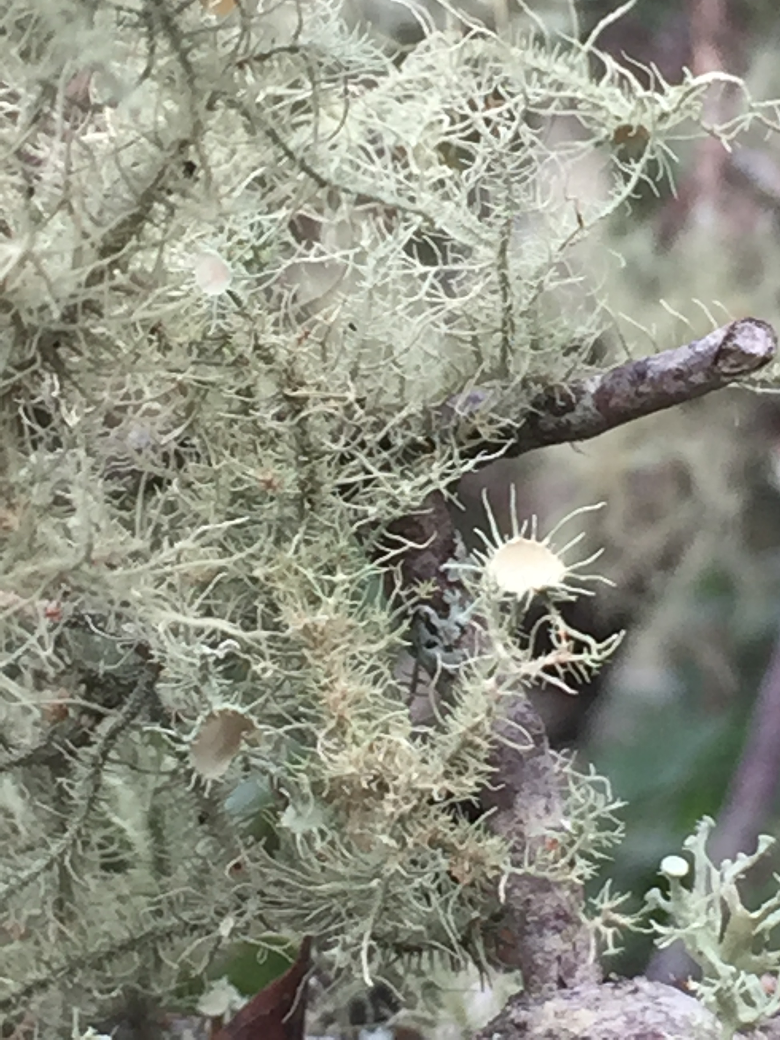 including U. barbata, U. bayle, U. californica, U. ceratine, U. dasypoga, U. diffracta, U. filipendula, U. florida, U. hirta, U. lobata, U. longissima, U. plicata*

Also known as: Beard Moss, Hair Lichen, Old Man’s Beard, Tree Moss, and Witch’s Broom

**Family:** Parmeliaceae or Usneaceae (Usnea Family)

**Location:** Throughout the world and on every continent

**Description:** Usnea derives from the Arabic word usna meaning moss. It is a grey/ yellow-green lichen (part fungus, part algae) that grows primarily in cool, damp forests on the branches and trunks of live or dead conifers, hardwoods and the odd variant such as coconut palms. It can grow from a few inches (small tufts) to 3 feet in length (resembling hair) and has a coarse, dry feel. It features a white, threadlike inner core. It is a very slow growing plant and its populations can be decimated by over harvesting. It is actually a symbiote composed of two plants intertwined: the thread like inner core which is a fungi and the sheath which is an algae. The algae provides the photosynthesis. The fungi provides water and minerals.

**Growing Conditions:** Grown outdoors in cool and moist forests

**Parts Used:** The whole lichen. The inner white thread is immune stimulating. The outer algae sheath is anti-bacterial.

**Uses:** Works against gram positive bacterially penetrating the cell walls, blocking the cell’s production of ATP rendering them useless. Used in the treatment of, bacterial infection, bronchitis, candida, chlamydia, colds, spastic colon, coughs, cystitis, UTI, diarrhea, dysentery, flu, giardia, gonorrhea, hemorrhage, impetigo, leukorrhea, lupus, mastitis, pleurisy, pneumonia, sinus infection, staph infection, strep throat, trichomonas, tuberculosis & urethritis

Topically: tea, diluted tincture or powdered herb may be applied directly to the skin to treat impetigo, ringworm and wounds. Included in foot powders for athlete’s foot. Prepared as a compress to treat eye inflammation or mastitis. As a gargle to treat throat infections. As a spray to treat sinus infections. As a tea in a douche or sits bath to treat candida, chlamydia, leukorrhea and trichomonas. In the wild, used can simply be chewed and swallowed. Staunch and protect open wounds.

Usnea was used to make capes, blankets and shoes. It is included in soaps and deodorants for its antibacterial properties. Has been used to line baby diapers and meade into menstrual pads utilizing its absorbent properties.

A yellow dye can be produced from it.

**Actions:** Analgesic, Antibacterial, Antibiotic, Antifungal, Anti-inflammatory, Antiparasitic, Antiseptic, Antispasmodic, Anti-tumor, Antiviral, Anti-mitotic, Antineoplastic, Antioxidant, Antiprotazoal, Inhibitor of biofilm formation, Bronchial Dilator, Expectorant, Febrifuge, Immune Stimulant, Vasodilator, Vulnerary. Effective against gram positive and gram negative bacteria, herpes simplex, Epstein Barr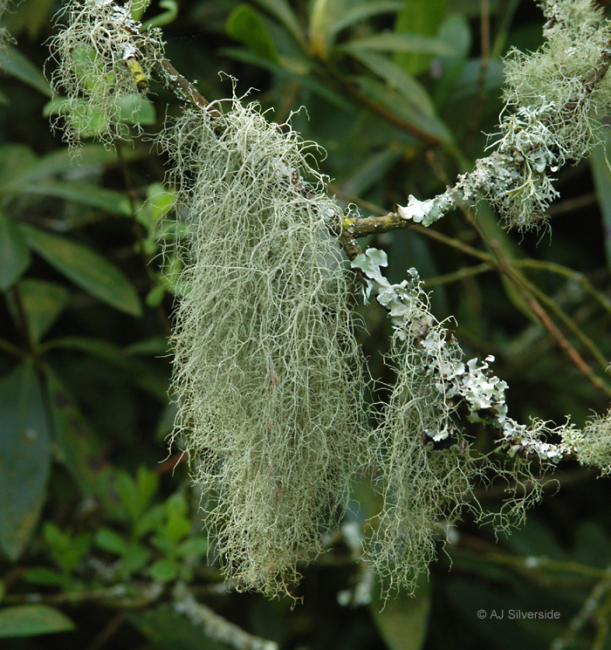

**Constituents:** Vit C, usnic acid, barbatic acid, lobaric acid, vulpinic acid, protolichesterinic acid, orcinol derivatives, longissiminone A and B, glutinol, ethyl hematommate, friedelin, beta-amyrin, beta-sitosterol, methyl-2, 4-dihydroxy-3, 6-dimethylbenzoate, zeorin, ehtyl orsellinate, 3-beta-hydroxy-glutin-5-ene, methylpolysaccharides & fatty acids (linoleic acid, oleic acid & arachidonic acid) and a lot…..lot more. About 50% of the plan is water soluble polysaccharides. Usnea harbors diverse fungi that are medicinally bioactive in themselves.

**Preparation:** best used as a tincture with heat. Grind to a powder before tincturing. You will be left with green powder and white threads. Use tincture ratio of 1:5 (1 part herb to 5 parts liquid) The liquid should be composed of half water and half pure grain alcohol. Put the herb into the half water amount and stir well. It will turn into a mush. This should be in a slow cooker or in a covered pot in the oven on low heat for 48 hours. Let cool until warm then into a heat tolerant jar then add the alcohol. Put on the lid and shake well. Let macerate for two weeks then decant and strain.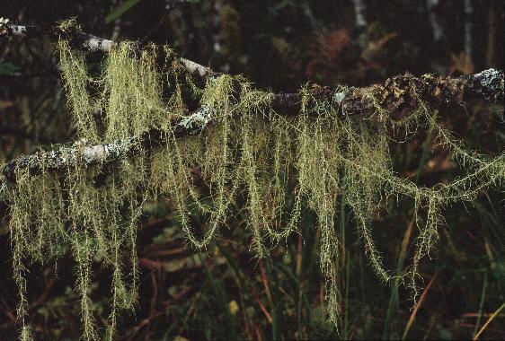

**Tincture:** 30-60 drops up to 4 times daily or in acute conditions 1/2-1 teaspoon 3-6 times daily

**Douche:** add 1/2 ounce of tincture to 1 pint of water. Douche twice daily. Once in the AM and once right before bed for three days

**Wash:** put the tincture or a 1:1 dilution in water directly on the affected area. Wash the site first thing in the AM and right before bed.

**Nasal Spray:** 10 drops of tincture with water in a 1 ounce nasal spray bottle. Use as needed.

**Tea:** 1 teaspoon of the herb with 6 ounces of hot water. Let steep for twenty minutes. Since unseat is only partly water soluble, grind the herb first then add enough alcohol to wet the herb. Let it soak covered for 30 minutes to an hour. Then add hot water and let steep for 15-30 minutes. 1 cup 3 times a day. In acute conditions drink up to 1 quart a day.

**Harvest:** Usnea can readily absorb toxic levels of heavy metals. Be sure to harvest 300 ft away from roads, factories, or polluted areas. Can be harvested at any time

**Psychology:**

**Flower Essence:**

**Combines:** For first aid: yarrow, plantain, red clover and oak. For UTI’s and cystitis: ova ours, dandelion and yarrow

**Flavor:** sweet, slightly bitter

**Constitution:**

**Pulse:**

**Tongue:**

**Temperature:** Cool

**Moisture:** Dry

**Polarity:** Yin

**Element:** Air

**Contra-Indications:** Avoid during pregnancy. Rare cases of contact dermatitis. Avoid during liver failure.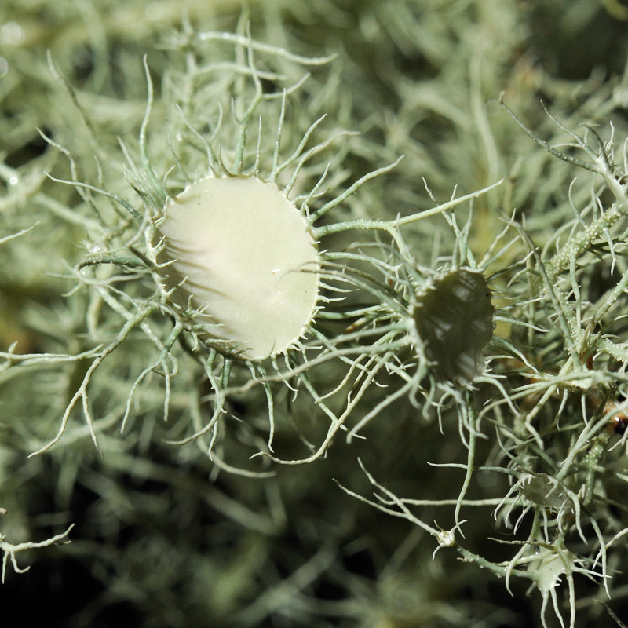

**References:**

***The Desktop Guide to Herbal Medicine*** by Brigitte Mars

***The Authentic Herbal Healer*** by Holly Bellebuono

***The Way of Herbs*** by Michael Tierra

***The Gift of Healing Herbs*** by Robin Rose Bennett

***Herbal Therapeutics*** by David Winston

**Herbal Antibiotics** by Stephen Harrod Buhner